

BRAC University
Department of Computer Science and Engineering

CSE427 : Machine Learning
Project Report
Summer 2026
Section 03
Group 09
Mahdi Rahman - 24141036
Kareeb Mahmud-21101158
Muhammed Bin Mijan-24101659

Dataset Identification

Field | Details
Name | AI vs Human Text Dataset
Source | https://www.kaggle.com/datasets/shanegerami/ai-vs-human-text/data
Format | CSV
Total Data | 487,235
Human Data | 305618
AI Data | 181438
Columns | Text, Generated

The dataset has a shape of ( 487,235 , 2), where 487,235 signifies the number of rows and 2 signifies the columns (text and generated). All 487,235 text records are unique. As we can see the dataset consists of about 62.7% human text and 37.3% AI text which is an acceptable imbalance.

Exploratory Data Analysis

Class Distribution Analysis
Initially we analysed the structure and the size of the dataset followed by df.unique to see it all the data are unique or not. Later to see the class imbalance of the dataset we drew up a count plot which indicates the imbalance between Ai and human data
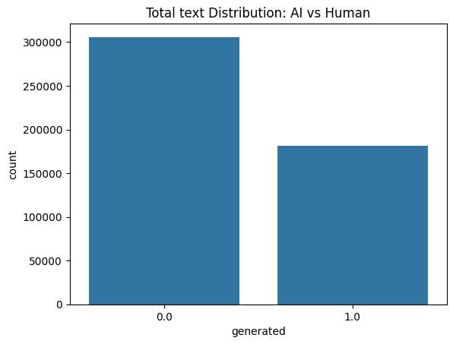
Fig 01: Count plot of the dataset

Feature Distribution Analysis
Initially we extracted 2 features from the dataset; respective KDE plots were made to compare the key feature difference between AI and Human text.
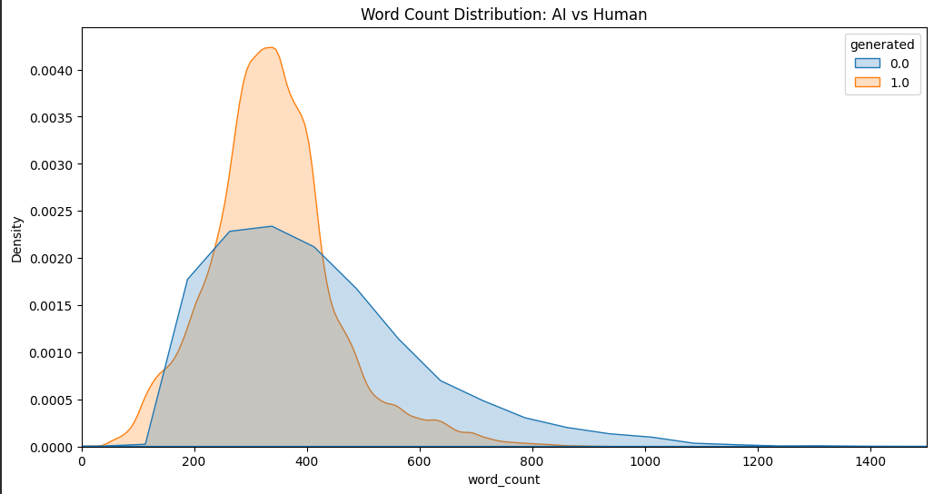
Fig 02: Word Count Distribution

As we can see, the orange peak is higher and narrower than the blue peak. Moreover it also proves a hypothesis of one the research paper we have read that the human generated text contains more burstiness and has the tendency to write more. However the difference is not that significant thus it won't be a good feature but a good data to hypothesize and used for other feature extraction.

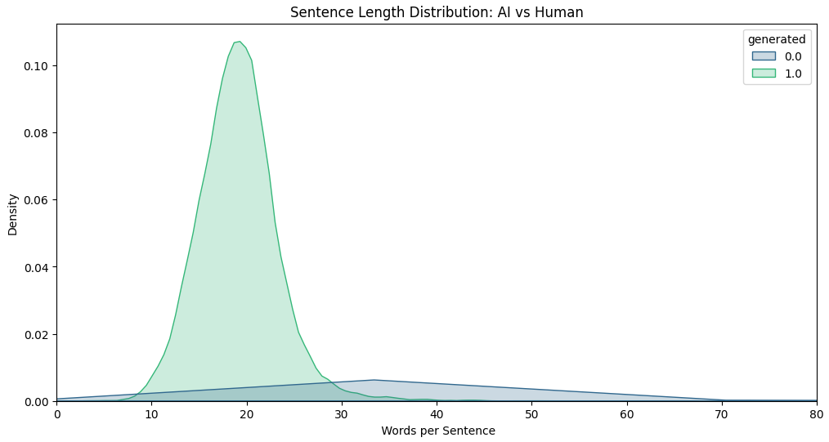
Fig 03: Sentence Length Distribution
On the contrary, for this graph we can see that the AI is very consistent with its number of words per sentence whereas the human text has a much higher density of short and long sentences. Moreover the AI peak is significantly larger than its human counterpart.

The involvement of a research paper we read related to our topic was significant in identifying and extracting further features from the dataset. We used a stylometric approach to extract 12 features that are visualized using a boxplot to compare the main distribution between AI and Human text. The following key observations were made:

- Burstiness: It is the variation in sentence structure and length which is used as a critical metric as AI generated text often exhibits a more uniform, grammatically standardized style, leading to lower burstiness.
- Entropy: Human text often shows a higher entropy which is the use of more unpredictable word choices, while AI texts are clustered at a lower, more consistent entropy score.
- Readability: Fk grade and Fog index were used that penalizes the complex word choices that AI sometimes uses and as we can see AI has scored consistently higher.
- Punctuation Density: Ratio of punctuation used per word were human texts shows more punctuations used whereas AI was more uniform
- Stopword Analysis: Ratio of stopwords to total words as we can see AI tends to use a predictable distribution of functional words.
- Lexical Diversity: Unique words used per total words as AI tends to have lower lexical diversity
- POS Tagging: Ratio of each POS tag to total words to see the different density of each pos tags

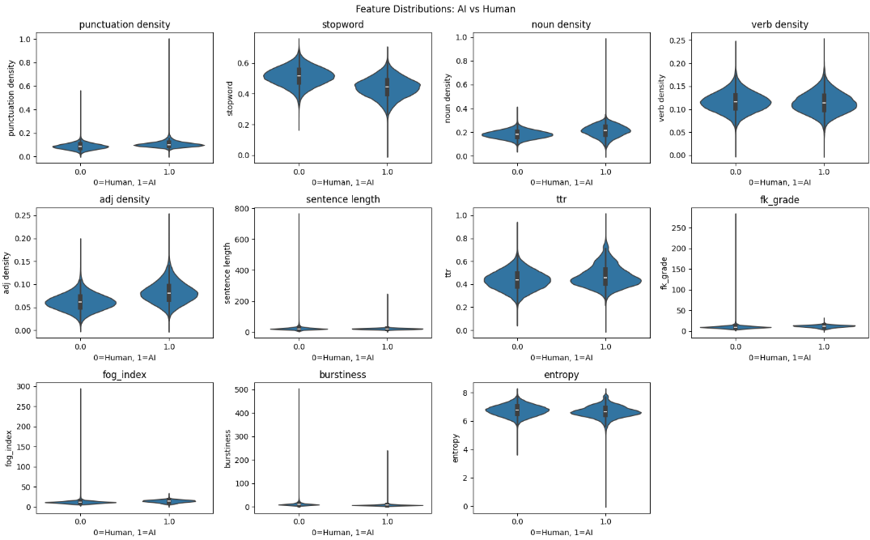
Fig 04: Violin plot for all the features
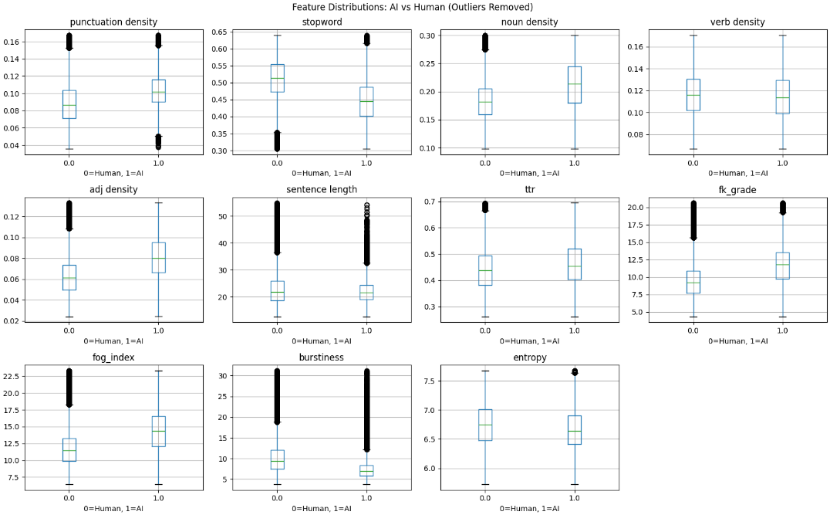
Fig 05: Box plot for all the features
Data Cleaning and Preparation

After feature extraction, the dataset was cleaned by replacing any infinite values with nan and dropping rows with missing values; however no rows were lost in this step. Features were then split into X (the 12 feature columns) and y ( target column). An 80/20 train-test split was applied. Finally, all features were standardized using StandardScaler to ensure no single feature dominated due to differences in scale.

Baseline Model Implementation

Three baseline classifiers were implemented and evaluated on the 12 extracted stylometric features. The models selected were logistic regression, random forest and gradient boosting.

Model | Accuracy | Precision | Recall | F1 Score
Logistic Regression | 87% | 0.86 | 0.85 | 0.86
Gradient Boosting | 91% | 0.90 | 0.89 | 0.90
Random Forest | 98% | 0.99 | 0.98 | 0.98

